**Exercise 1: Configuring a Basic Spring Application**

**pom.xml:**

<project xmlns="http://maven.apache.org/POM/4.0.0" xmlns:xsi="http://www.w3.org/2001/XMLSchema-instance" xsi:schemaLocation="http://maven.apache.org/POM/4.0.0 https://maven.apache.org/xsd/maven-4.0.0.xsd">

<modelVersion>4.0.0</modelVersion>

<groupId>com.library</groupId>

<artifactId>LibraryManagement</artifactId>

<version>0.0.1-SNAPSHOT</version>

<dependencies>

<dependency>

<groupId>org.springframework</groupId>

<artifactId>spring-context</artifactId>

<version>5.3.25</version>

</dependency>

</dependencies>

</project>

**applicationContext.xml:**

<?xml version="1.0" encoding="UTF-8"?>

<beans xmlns="http://www.springframework.org/schema/beans"

xmlns:xsi="http://www.w3.org/2001/XMLSchema-instance"

xsi:schemaLocation="

http://www.springframework.org/schema/beans

https://www.springframework.org/schema/beans/spring-beans.xsd">

<bean id="bookRepository" class="com.library.repository.BookRepository"/>

<bean id="bookService" class="com.library.service.BookService">

<property name="bookRepository" ref="bookRepository"/>

</bean>

</beans>

**BookService**.**java:**

package com.library.service;

import com.library.repository.BookRepository;

public class BookService {

private BookRepository bookRepository;

public void setBookRepository(BookRepository bookRepository) {

this.bookRepository = bookRepository;

}

public void addBook() {

System.*out*.println("BookService: Adding book...");

bookRepository.saveBook();

}

}

**BookRepository**.**java:**

package com.library.repository;

public class BookRepository {

public void saveBook() {

System.*out*.println("Book saved to repository.");

}

}

**MainApp.java:**

package com.library;

import com.library.service.BookService;

import org.springframework.context.support.ClassPathXmlApplicationContext;

public class MainApp {

public static void main(String[] args) {

ClassPathXmlApplicationContext context = new ClassPathXmlApplicationContext("applicationContext.xml");

BookService bookService = (BookService) context.getBean("bookService");

bookService.addBook();

context.close();

}

}

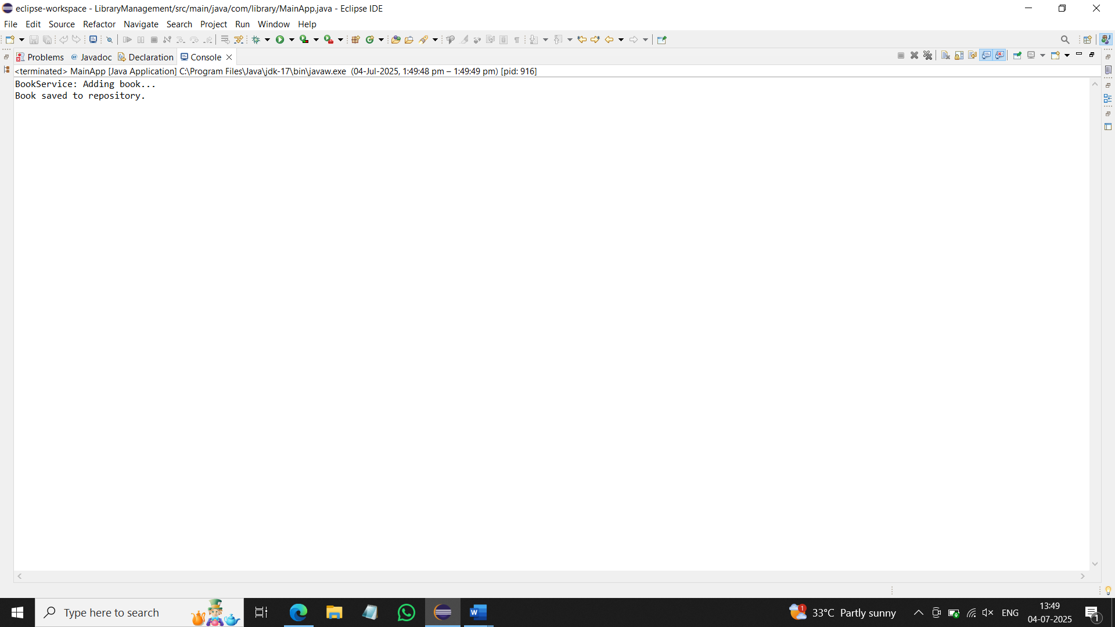

**Exercise 2: Implementing Dependency Injection**

1. **Modify the XML Configuration:**
   * Update **applicationContext.xml** to wire **BookRepository** into **BookService**.

<?xml version="1.0" encoding="UTF-8"?>

<beans xmlns="http://www.springframework.org/schema/beans"

xmlns:xsi="http://www.w3.org/2001/XMLSchema-instance"

xsi:schemaLocation="http://www.springframework.org/schema/beans

https://www.springframework.org/schema/beans/spring-beans.xsd">

<bean id="bookRepository" class="com.library.repository.BookRepository"/>

<bean id="bookService" class="com.library.service.BookService">

<property name="bookRepository" ref="bookRepository"/>

</bean>

</beans>

1. **Update the BookService Class:**
   * Ensure that **BookService** class has a setter method for **BookRepository**.

package com.library.service;

import com.library.repository.BookRepository;

public class BookService {

private BookRepository bookRepository;

public void setBookRepository(BookRepository bookRepository) {

this.bookRepository = bookRepository;

}

public void addBook() {

System.*out*.println("BookService: Adding book...");

bookRepository.saveBook();

}

}

1. **Test the Configuration:**
   * Run the **LibraryManagementApplication** main class to verify the dependency injection.

package com.library;

import com.library.service.BookService;

import org.springframework.context.support.ClassPathXmlApplicationContext;

public class MainApp {

public static void main(String[] args) {

ClassPathXmlApplicationContext context = new ClassPathXmlApplicationContext("applicationContext.xml");

BookService bookService = (BookService) context.getBean("bookService");

bookService.addBook();

context.close();

}

}

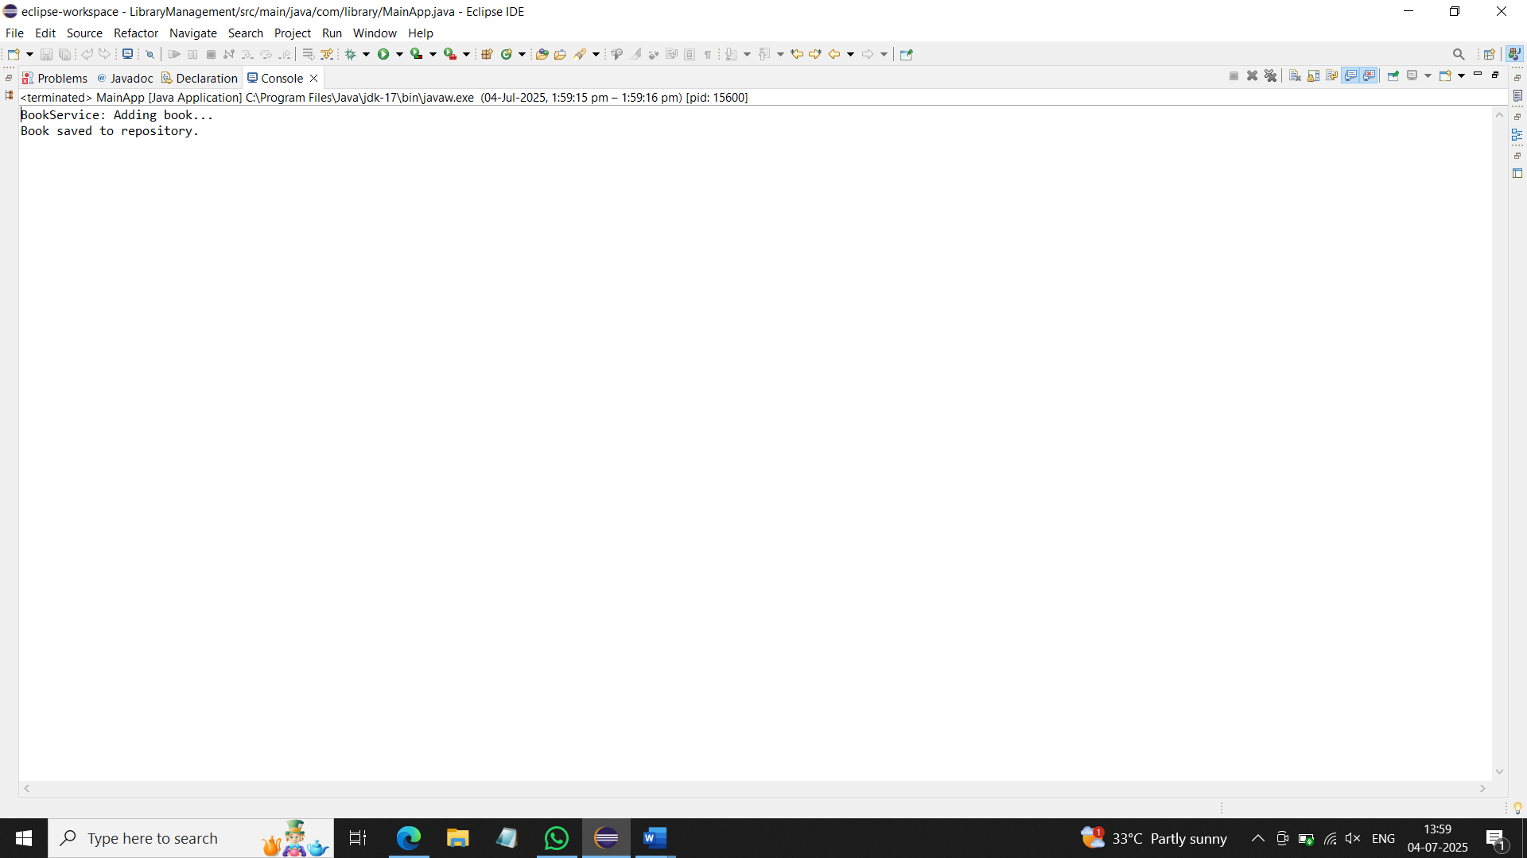

**Exercise 4: Creating and Configuring a Maven Project**

1. **Add Spring Dependencies in pom.xml:**
   * Include dependencies for Spring Context, Spring AOP, and Spring WebMVC.
2. **Configure Maven Plugins:**
   * Configure the Maven Compiler Plugin for Java version 1.8 in the pom.xml file.

<project xmlns="http://maven.apache.org/POM/4.0.0" xmlns:xsi="http://www.w3.org/2001/XMLSchema-instance" xsi:schemaLocation="http://maven.apache.org/POM/4.0.0 https://maven.apache.org/xsd/maven-4.0.0.xsd">

<modelVersion>4.0.0</modelVersion>

<groupId>com.library</groupId>

<artifactId>LibraryManagement</artifactId>

<version>0.0.1-SNAPSHOT</version>

<dependencies>

<dependency>

<groupId>org.springframework</groupId>

<artifactId>spring-context</artifactId>

<version>5.3.25</version>

</dependency>

<dependency>

<groupId>org.springframework</groupId>

<artifactId>spring-aop</artifactId>

<version>5.3.25</version>

</dependency>

<dependency>

<groupId>org.springframework</groupId>

<artifactId>spring-webmvc</artifactId>

<version>5.3.25</version>

</dependency>

</dependencies>

<build>

<plugins>

<plugin>

<groupId>org.apache.maven.plugins</groupId>

<artifactId>maven-compiler-plugin</artifactId>

<version>3.8.1</version>

<configuration>

<source>1.8</source>

<target>1.8</target>

</configuration>

</plugin>

</plugins>

</build>

</project>

**Exercise 5: Configuring the Spring IoC Container**

1. **Create Spring Configuration File:**
   * Create an XML configuration file named **applicationContext.xml** in the **src/main/resources** directory.
   * Define beans for **BookService** and **BookRepository** in the XML file.

<?xml version="1.0" encoding="UTF-8"?>

<beans xmlns="http://www.springframework.org/schema/beans"

xmlns:xsi="http://www.w3.org/2001/XMLSchema-instance"

xsi:schemaLocation="

http://www.springframework.org/schema/beans

https://www.springframework.org/schema/beans/spring-beans.xsd">

<bean id="bookRepository" class="com.library.repository.BookRepository"/>

<bean id="bookService" class="com.library.service.BookService">

<property name="bookRepository" ref="bookRepository"/>

</bean>

</beans>

1. **Update the BookService Class:**
   * Ensure that the **BookService** class has a setter method for **BookRepository**.

package com.library.service;

import com.library.repository.BookRepository;

public class BookService {

private BookRepository bookRepository;

public void setBookRepository(BookRepository bookRepository) {

this.bookRepository = bookRepository;

}

public void addBook() {

System.*out*.println("BookService: Adding book...");

bookRepository.saveBook();

}

}

1. **Run the Application:**

* Create a main class to load the Spring context and test the configuration.

package com.library;

import com.library.service.BookService;

import org.springframework.context.support.ClassPathXmlApplicationContext;

public class MainApp {

public static void main(String[] args) {

ClassPathXmlApplicationContext context = new ClassPathXmlApplicationContext("applicationContext.xml");

BookService bookService = (BookService) context.getBean("bookService");

bookService.addBook();

context.close();

}

}

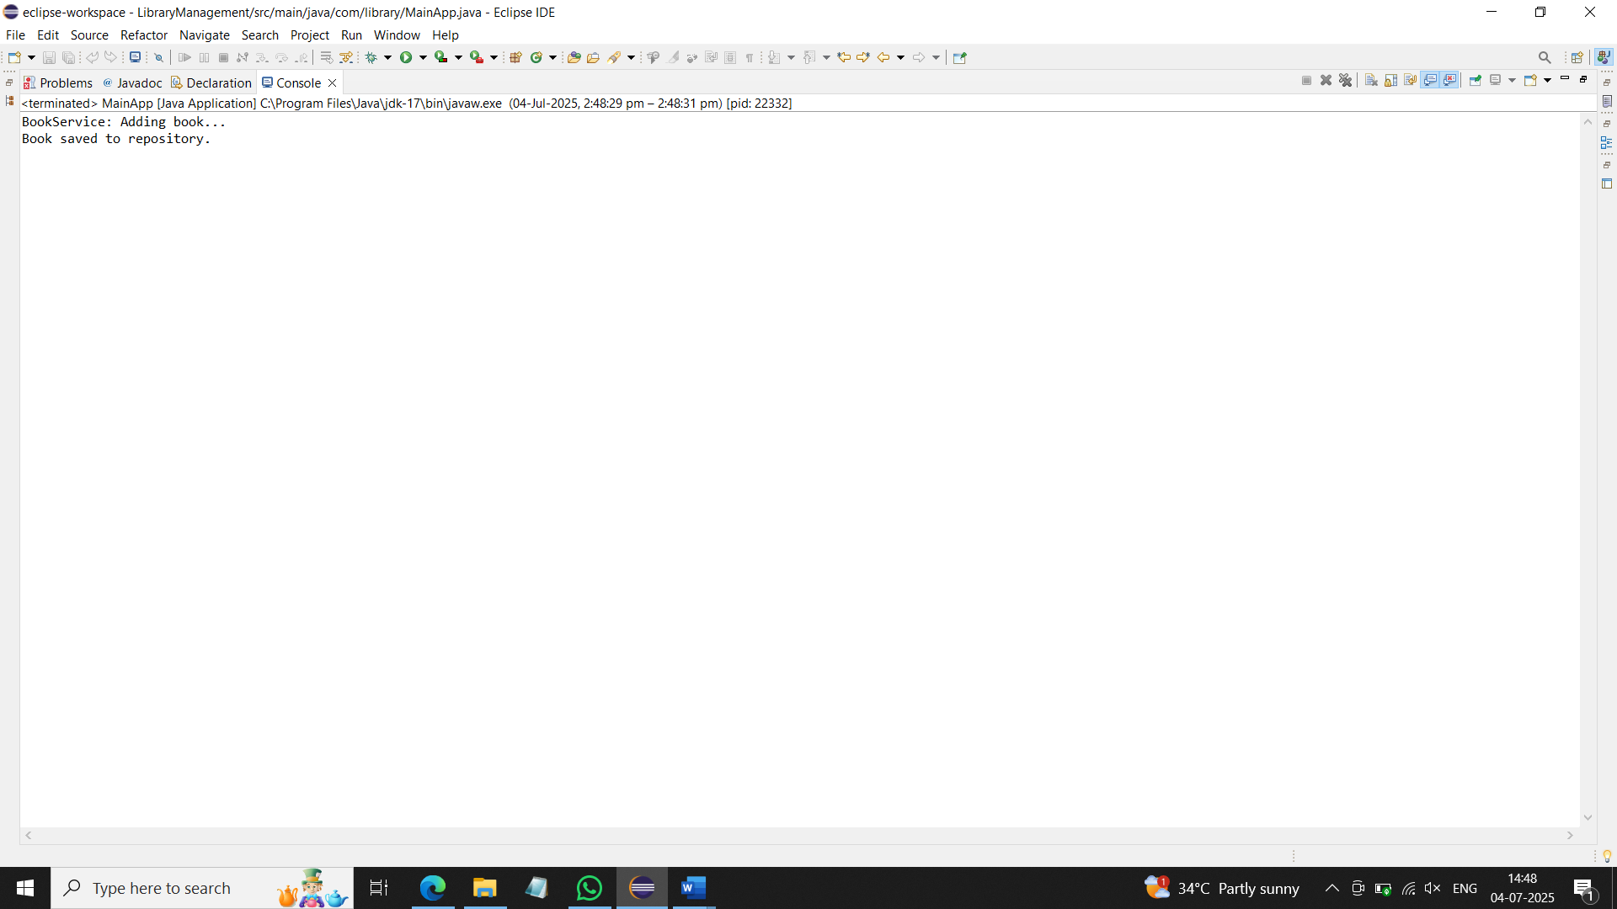

**Exercise 7: Implementing Constructor and Setter Injection**

1. **Configure Constructor Injection:**
   * Update applicationContext.**xml** to configure constructor injection for **BookService**.

<?xml version="1.0" encoding="UTF-8"?>

<beans xmlns="http://www.springframework.org/schema/beans"

xmlns:xsi="http://www.w3.org/2001/XMLSchema-instance"

xsi:schemaLocation="

http://www.springframework.org/schema/beans

https://www.springframework.org/schema/beans/spring-beans.xsd">

<bean id="bookRepository" class="com.library.repository.BookRepository"/>

<bean id="bookService" class="com.library.service.BookService">

<constructor-arg value="Library Management Service"/>

<property name="bookRepository" ref="bookRepository"/>

</bean>

</beans>

1. **Configure Setter Injection:**
   * Ensure that the **BookService** class has a setter method for **BookRepository** and configure it in **applicationContext.xml**.

package com.library.service;

import com.library.repository.BookRepository;

public class BookService {

private String serviceName;

private BookRepository bookRepository;

public BookService(String serviceName) {

this.serviceName = serviceName;

}

public void setBookRepository(BookRepository bookRepository) {

this.bookRepository = bookRepository;

}

public void addBook() {

System.*out*.println(serviceName + ": Adding book...");

bookRepository.saveBook();

}

}

1. **Test the Injection:**
   * Run the **LibraryManagementApplication** main class to verify both constructor and setter injection.

package com.library;

import com.library.service.BookService;

import org.springframework.context.support.ClassPathXmlApplicationContext;

public class MainApp {

public static void main(String[] args) {

try (ClassPathXmlApplicationContext context = new ClassPathXmlApplicationContext("applicationContext.xml")) {

BookService bookService = context.getBean("bookService", BookService.class);

bookService.addBook();

}

}

}

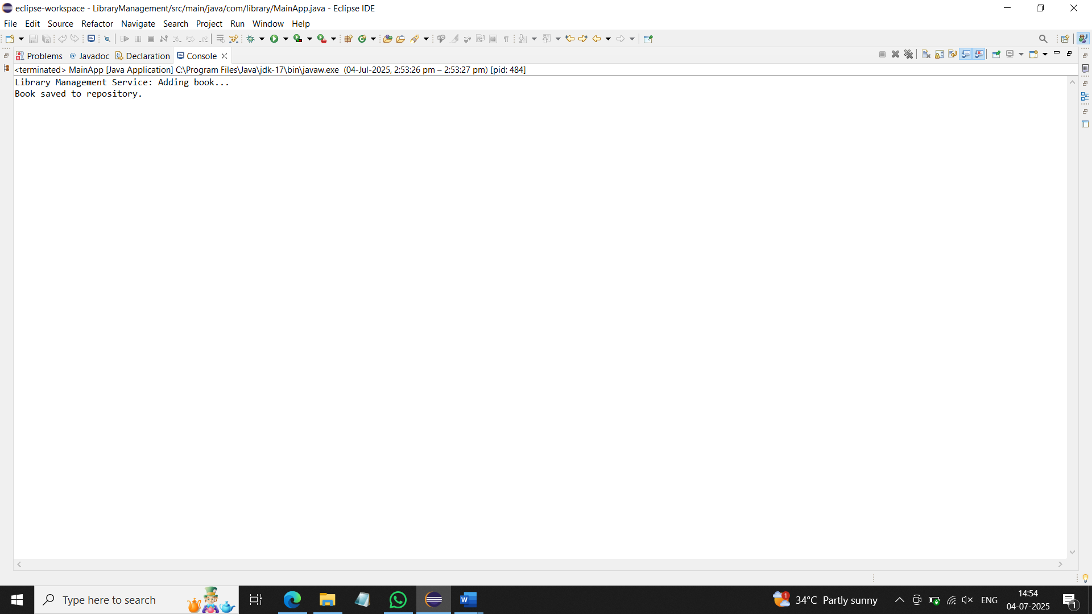

**Exercise 9: Creating a Spring Boot Application**

1. **Create a Spring Boot Project:**
   * **Use Spring Initializr to create a new Spring Boot project named LibraryManagement.**
2. **Add Dependencies:**
   * **Include dependencies for Spring Web, Spring Data JPA, and H2 Database.**
3. **Create Application Properties:**
   * **Configure database connection properties in application.properties.**

spring.application.name=LibraryManagement

# H2 Database configuration

spring.datasource.url=jdbc:h2:mem:librarydb

spring.datasource.driverClassName=org.h2.Driver

spring.datasource.username=sa

spring.datasource.password=

# JPA settings

spring.jpa.database-platform=org.hibernate.dialect.H2Dialect

spring.jpa.hibernate.ddl-auto=update

# Enable H2 console

spring.h2.console.enabled=true

1. **Define Entities and Repositories:**
   * **Create Book entity and BookRepository interface.**

**Book.java:**

package com.library.LibraryManagement.entity;

import jakarta.persistence.Entity;

import jakarta.persistence.GeneratedValue;

import jakarta.persistence.GenerationType;

import jakarta.persistence.Id;

@Entity

public class Book {

@Id

@GeneratedValue(strategy = GenerationType.*IDENTITY*)

private Long id;

private String title;

private String author;

public Long getId() {

return id;

}

public void setId(Long id) {

this.id = id;

}

public String getTitle() {

return title;

}

public void setTitle(String title) {

this.title = title;

}

public String getAuthor() {

return author;

}

public void setAuthor(String author) {

this.author = author;

}

}

**BookRepository.java:**

package com.library.LibraryManagement.repository;

import com.library.LibraryManagement.entity.Book;

import org.springframework.data.jpa.repository.JpaRepository;

import org.springframework.stereotype.Repository;

@Repository

public interface BookRepository extends JpaRepository<Book, Long> {

}

1. **Create a REST Controller:**
   * **Create a BookController class to handle CRUD operations.**

package com.library.LibraryManagement.controller;

import com.library.LibraryManagement.entity.Book;

import com.library.LibraryManagement.repository.BookRepository;

import org.springframework.beans.factory.annotation.Autowired;

import org.springframework.web.bind.annotation.*;

import java.util.List;

@RestController

@RequestMapping("/books")

public class BookController {

@Autowired

private BookRepository bookRepository;

@GetMapping

public List<Book> getAllBooks() {

return bookRepository.findAll();

}

@GetMapping("/{id}")

public Book getBookById(@PathVariable Long id) {

return bookRepository.findById(id).orElse(null);

}

@PostMapping

public Book createBook(@RequestBody Book book) {

return bookRepository.save(book);

}

@PutMapping("/{id}")

public Book updateBook(@PathVariable Long id, @RequestBody Book bookDetails) {

Book book = bookRepository.findById(id).orElse(null);

if (book != null) {

book.setTitle(bookDetails.getTitle());

book.setAuthor(bookDetails.getAuthor());

return bookRepository.save(book);

}

return null;

}

@DeleteMapping("/{id}")

public void deleteBook(@PathVariable Long id) {

bookRepository.deleteById(id);

}

}

1. **Run the Application:**
   * **Run the Spring Boot application and test the REST endpoints.**

package com.library.LibraryManagement;

import org.springframework.boot.SpringApplication;

import org.springframework.boot.autoconfigure.SpringBootApplication;

@SpringBootApplication

public class LibraryManagementApplication {

public static void main(String[] args) {

SpringApplication.*run*(LibraryManagementApplication.class, args);

}

}

